Lab Report 4

*Name: Sricharan Vinoth Kumar*

*Roll no: 2024112022*

*Group no: 10*

Experiment 1:

* Objective:

To assemble a 4x1 multiplexer and observe its working.

* Electronic Components Used:
  + 7404 Hex Inverter
  + 7411 3-Input AND IC
  + 7432 2-Input OR IC
  + Digital Test Kit
* Reference Circuit:

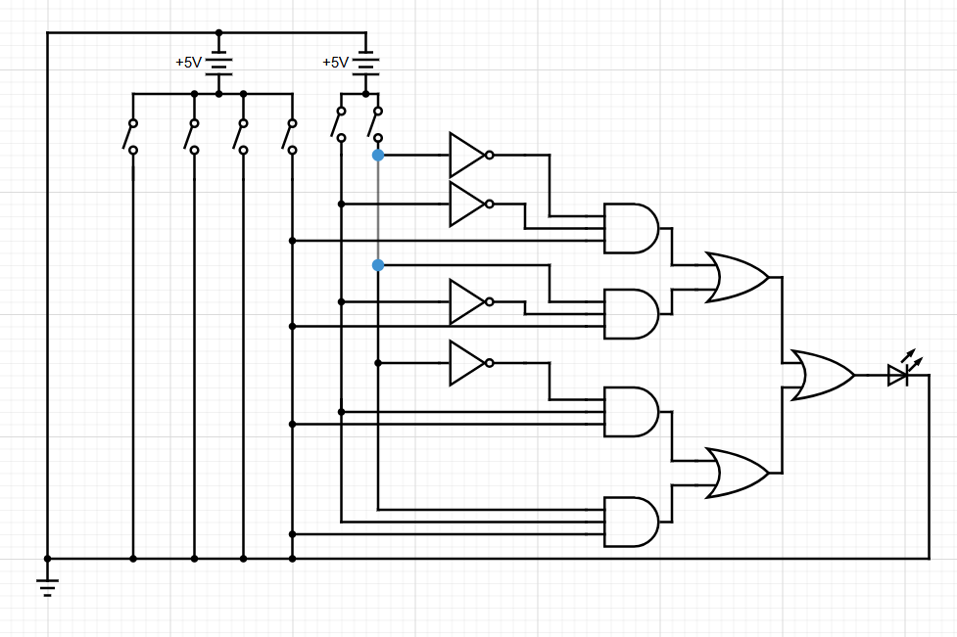

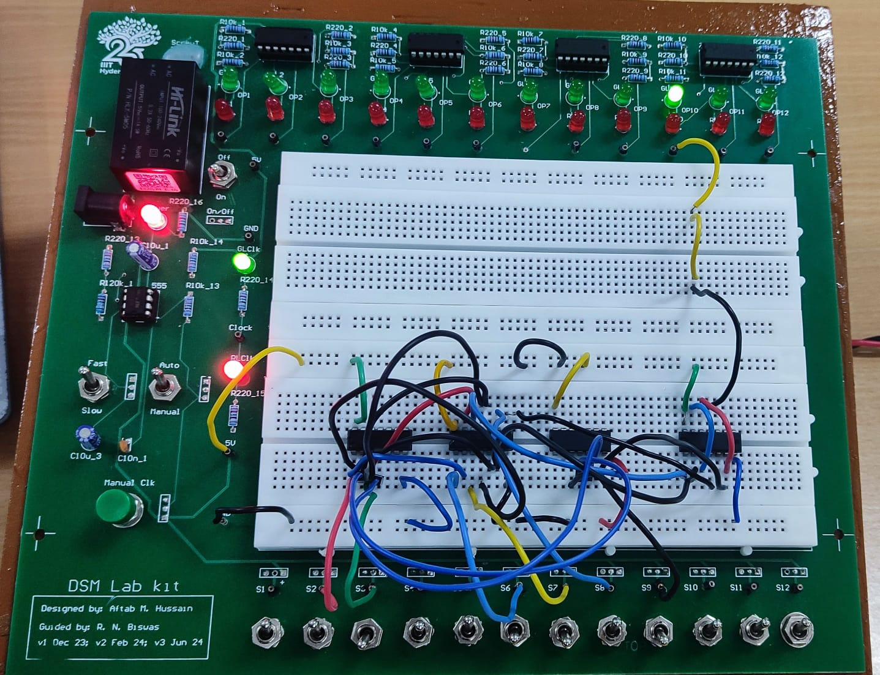

* Procedure:
  1. Ensure that the input pins IP1-12 and output LEDs LG1-12 and LR1-12 are working. Set the CLOCK of the kit in FAST mode.
  2. Assemble the 4 x 1 Multiplexer as shown in the given circuit diagram.
  3. Give different combinations of inputs to the selection lines S0 and S1 and to the inputs I0, I1, I2, I3, and draw the truth table for the outputs.
  4. Verify the function of the Multiplexer by checking the truth table.
* Observation:

The observed Truth Table was:

|  |  |  |
| --- | --- | --- |
| S0 | S1 | Out |
| 0 | 0 | I0 |
| 0 | 1 | I1 |
| 1 | 0 | I2 |
| 1 | 1 | I3 |

* Conclusion:

The 4 x 1 Multiplexer has been assembled successfully.

* TinkerCAD Simulation:

<https://www.tinkercad.com/things/9BQHzFksia7-dsm-lab-4-exp-1?sharecode=UjYG-72zlE_TJ630N16Hz0Gwddj9Gw8xJbPZJIAx9_I>

Experiment 2:

* Objective:

To assemble a 1 x 4 Demultiplexer and observe its working.

* Electronic Components:
  + 7404 Hex Inverter
  + 7411 3-Input AND IC
  + Digital Test Kit
* Reference Circuit:

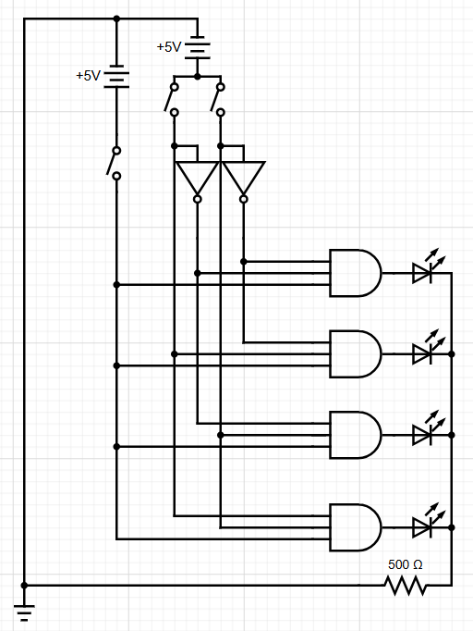

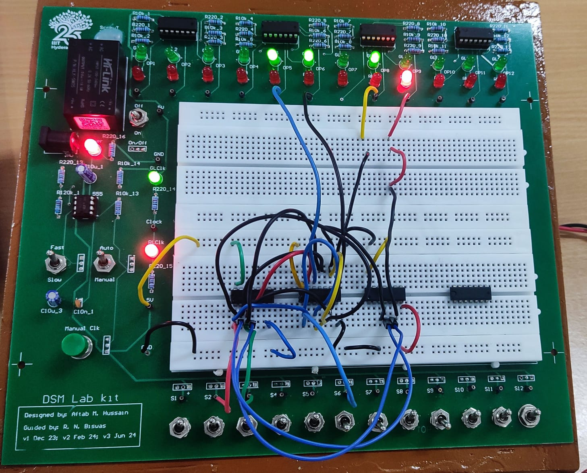

* Procedure:
  1. Ensure that the input pins IP1-12 and output LEDs LG1-12 and LR1-12 are working. Set the CLOCK of the kit in FAST mode.
  2. Assemble the 1 x 4 Demultiplexer as shown in the given circuit diagram.
  3. Give different combinations of inputs to the selection lines S0 and S1 and to the input I and draw the truth table for the outputs O0, O1, O2, O3.
  4. Verify the function of the Demultiplexer by checking the truth table.
* Observation;

Observed truth table:

|  |  |  |  |  |  |
| --- | --- | --- | --- | --- | --- |
| S0 | S1 | O0 | O1 | O2 | O3 |
| 0 | 0 | **I** | 0 | 0 | 0 |
| 0 | 1 | 0 | **I** | 0 | 0 |
| 1 | 0 | 0 | 0 | **I** | 0 |
| 1 | 1 | 0 | 0 | 0 | **I** |

* Conclusion:

The 1 x 4 Demultiplexer has been assembled successfully.

* TinkerCAD Simulation:

<https://www.tinkercad.com/things/aMexKApZ4eK-dsm-lab-4-exp-2?sharecode=SrXOc6lBEz6kO1tJshI7flqMcByYjs5xPBusE0rrrF4>

Experiment 3:

* Objective:

To connect a 4 x 1 Multiplexer and a 1 x 4 Demultiplexer and observe their function.

* Electronic Components Used:
  + 74153 4 x 1 Multiplexer IC
  + 74139 1 x 4 Demultiplexer IC
  + Digital Test Kit
* Reference Circuit:

* Procedure:
  1. Ensure that the input pins IP1-12 and output LEDs LG1-12 and LR1-12 are working. Set the CLOCK of the kit in FAST mode.
  2. Connect any 4 of the input switches to the 4 x 1 Multiplexer IC and connect its output to the Demultiplexer IC. Connect the outputs of the Demultiplexer IC to any of the 4 output LEDs.
  3. Give different combinations of inputs to the selection lines S0 and S1 and to the inputs I0, I1, I2, I3, and draw the truth table for the outputs O0, O1, O2, O3.
  4. Verify the function of this combined circuit by checking the truth table.
* Observation:

The obtained truth table is:

|  |  |  |  |  |  |
| --- | --- | --- | --- | --- | --- |
| S0 | S1 | O0 | O1 | O2 | O3 |
| 0 | 0 | **I0** | 0 | 0 | 0 |
| 0 | 1 | 0 | **I1** | 0 | 0 |
| 1 | 0 | 0 | 0 | **I2** | 0 |
| 1 | 1 | 0 | 0 | 0 | **I3** |

* Conclusion:

The Multiplexer and Demultiplexer combination circuit has been assembled and its function has been analysed.

* TinkerCAD Simulation:

<https://www.tinkercad.com/things/9nARe3ujAqp-dsm-lab-4-exp-3?sharecode=9e9HjdU-LMj8nvJLrb_L60PxuL68mo19SLQaj7_dNeo>